Physical Records Management

Hello and welcome to the Try Lab for Physical Records Management using OnBase. Here you will see how users can submit a request to either retrieve, create, transfer, or destroy a physical record. The purpose of this lab will be to walk through the record retrieval process specifically.

* [Requesting a Record](https://labclient.labondemand.com/Instructions/9cf7bb8f-05f2-4696-8dab-8901d1830ea2?rc=10#requesting-a-record)
* [Record Collection Review](https://labclient.labondemand.com/Instructions/9cf7bb8f-05f2-4696-8dab-8901d1830ea2?rc=10#record-collection-review)
* [Record Storage Administration](https://labclient.labondemand.com/Instructions/9cf7bb8f-05f2-4696-8dab-8901d1830ea2?rc=10#record-storage-administration)
* [Notifications](https://labclient.labondemand.com/Instructions/9cf7bb8f-05f2-4696-8dab-8901d1830ea2?rc=10#notifications)
* [Additional Resources](https://labclient.labondemand.com/Instructions/9cf7bb8f-05f2-4696-8dab-8901d1830ea2?rc=10#additional-resources)

You can leverage dual monitors for the lab by separating the instruction panel from the lab. Simply click "Split Windows" in the menu options.  
  
  
  
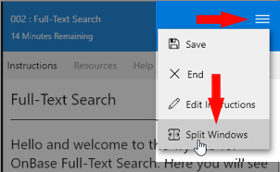

# Requesting a Record

In this example you will see how an employee can submit physical records request from outside of OnBase. The form will be completed from a web browser where the requestor provides as much information as possible about the records they're requesting.

1. Launch Chrome.



1. Select the **Physical Record Request Form** from the Physical Records Management bookmark menu.

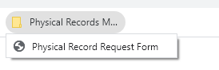

Notice that the form is loaded from within the web browser. This is an example of a "Shared" Unity Form which can be made available to non-OnBase users.

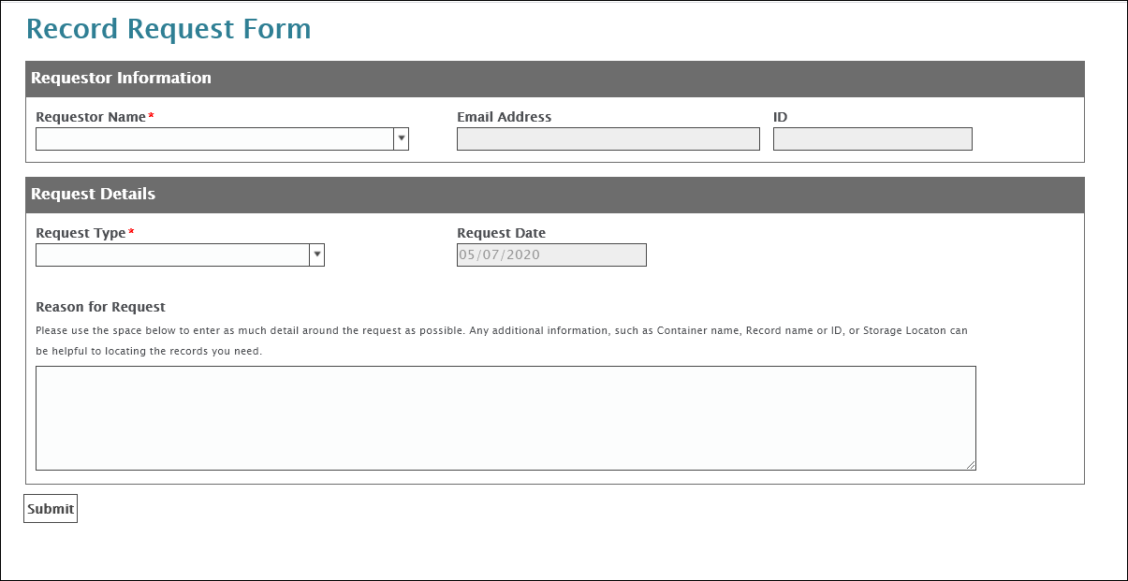

1. **Begin typing Bella Dyer** in the employee name field.

Notice that the list of users is automatically updated as you begin typing in the name of the employee.

This form has been designed to require the user to select employee name instead of auto-populating the field. This allows a user to submit a request on behalf of another employee should that other employee not have the ability to complete the form. The form however could be configured to automatically populate the employee name field based on the user submitting it.

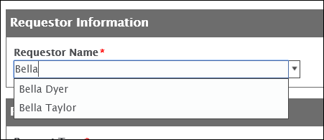

1. Select **Retrieve** from the Request Type Drop down. The form is dynamic in that additional fields may be presented to the user based on the type of request selected.

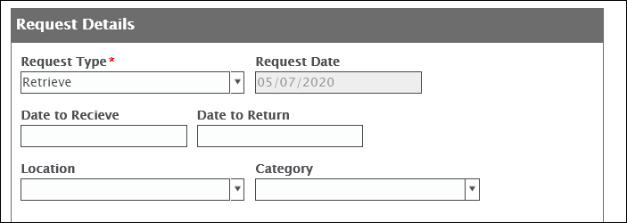

1. Select a Date to Receive, Date to Return, and Record Category.

Note: These fields are not required but are recommended in to order to help provide more information to the records manager around the request. Knowing the dates that the records are needed by will help set delivery date. Information such as location and category is helpful to track down the records you are looking to request. The location is optional as a user may or may not know the location of the records being requested.

1. Enter a Reason for the Request. In this case, we will request all the red Legal Files in order to review the contracts in the box.

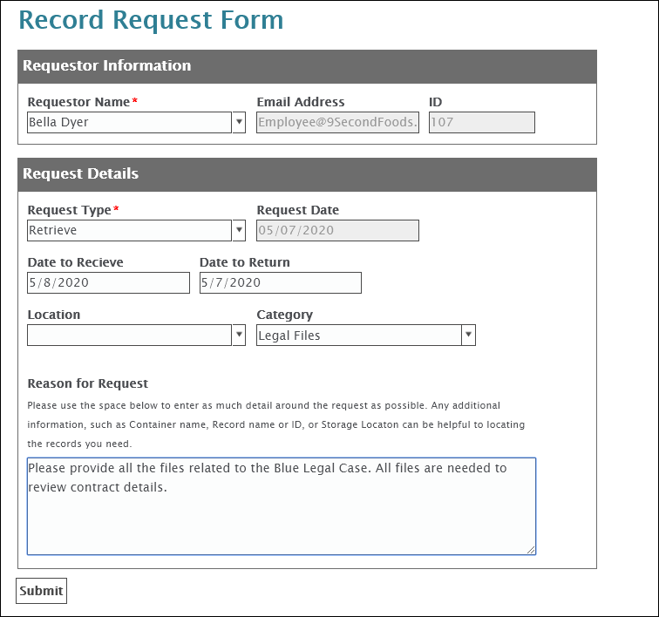

1. Click **Submit** once all information has been entered into the form.

The user is presented with a confirmation page that they have successfully submitted the form along with an email to confirm a receipt of the request.



# Record Collection Review

In this example you will see how record managers can quickly see requests that have been submitted as well as take the appropriate action.

1. Login to the Web Client using the credentials listed below.

**Username:** **records**  
**Password:** **password**



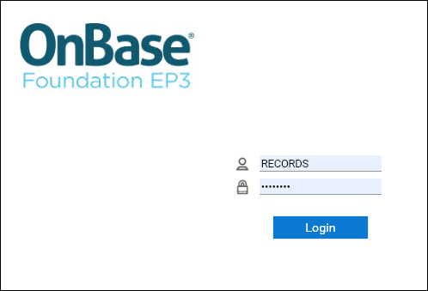

1. Select Open WorkView from the Web Client menu.

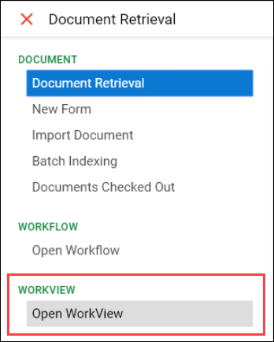

Notice that a list of unassigned requests presents automatically. Record Managers can select a request from the list in order to assign themselves and start working the request. Notice the object created from the previous section at the top.

1. Double click on the new result to open it.

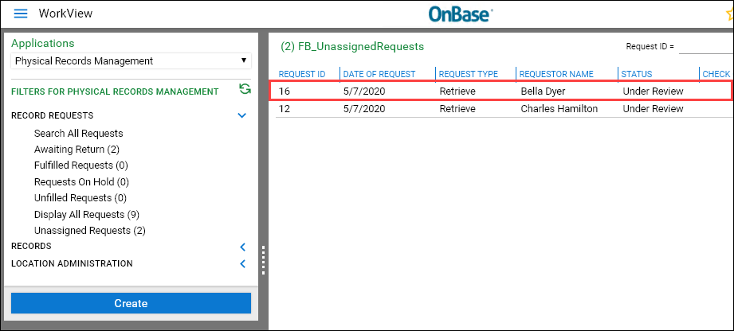

Upon opening the request, you can review the request details on the left hand side of the screen. As the record administrator you determine that this is a request that should continue forward.

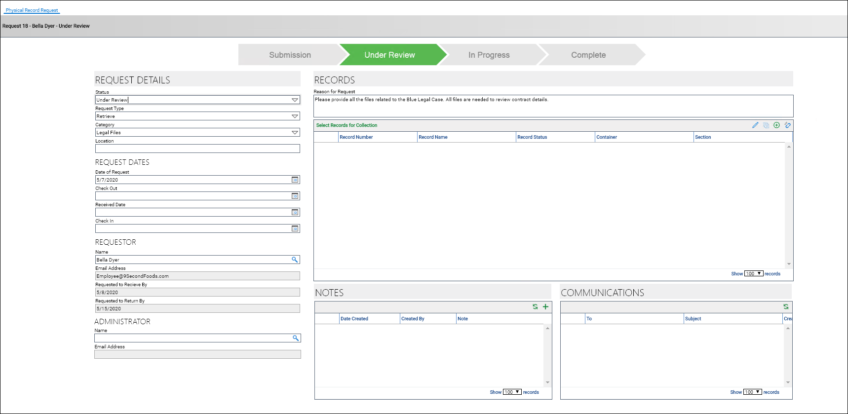

1. Select **Assign Myself and Approve** in order to assign the current user as the administrator for this request. Completing this action also moves the request into the "Under Review" status.

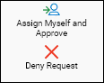

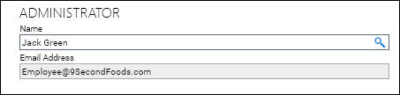

1. At this point the administrator now has the option to request more information or collect the records for retrieval. Since we already can see from the request that we want all the files from the red Legal box.

Notice the current user is now placed in the Administrator field. To do so, **click the (+) add button** on the Select Records for Collection filter.

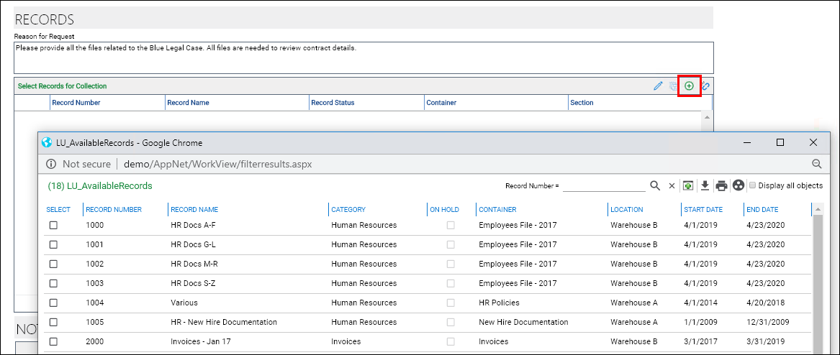

1. In the top right hand corner, **click the group by icon and select Container**. Then, select all the items in the red Legal container by selecting the checkbox next to the record. Once the checkbox is selected, **click the Add checked objects to list button**.

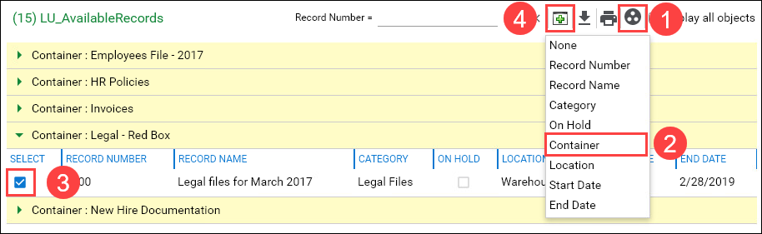

1. After collection is complete, **click the Record Collection Complete** action in the task panel to move the request forward.

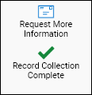

Notice that the status of the selected record has also been updated so that it cannot be checked out to another requestor. The status will switch back once the records have been returned.

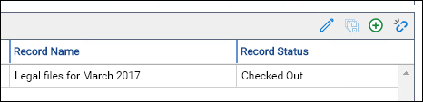

It's now time to notify both the Location and Requestor of the pending delivery.

1. Click **Notify Location** to send a notification to the location where the records are stored. The user is provided a prompt to enter the message that will be sent.

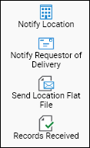

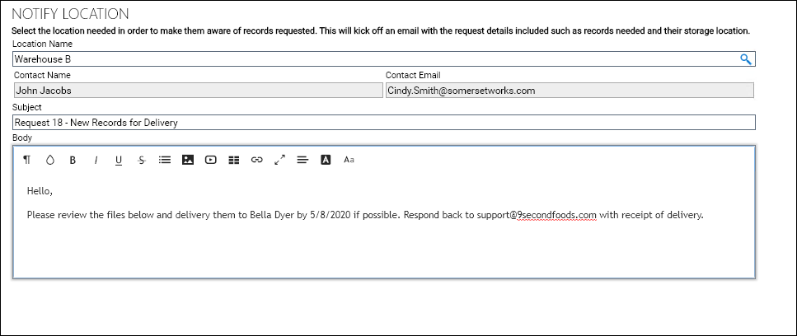

Once the location confirms when they will deliver, the Notify Requestor of Delivery action allows you to send a notification to the requestor informing them of when the delivery will take place.

1. Click **Notify Requestor of Delivery**

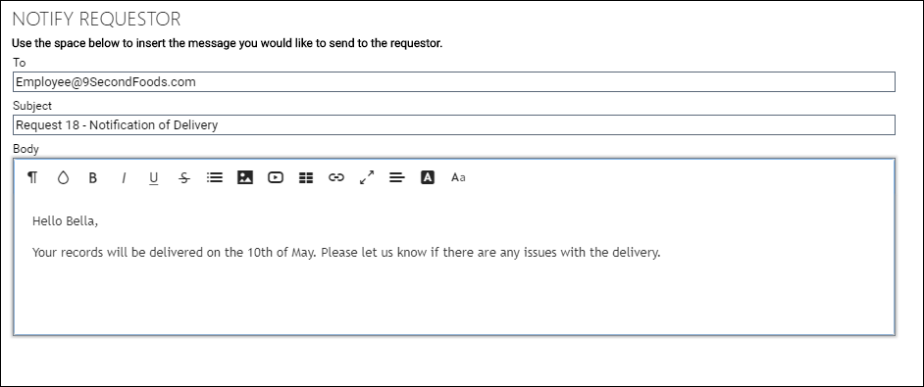

Once both parties have been notified, select Records Received to confirm the records are delivered to the employee and pending return now.

# Record Storage Administration

In this example you will see how an administrator can easily manage various components of the solution.

1. Login to the Web Client using the credentials listed below.

**Username:** **records**  
**Password:** **password**





1. Select Open WorkView from the Web Client menu.



1. Select Admin Panel within the LOCATION ADMINISTRATION section and double click on the Physical Records Management item listed to open it.

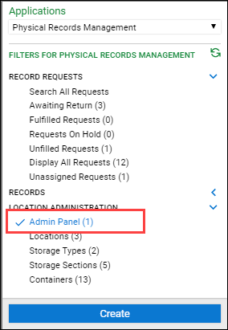

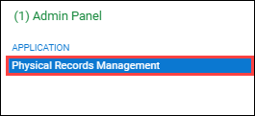

The Admin Panel view contains many of the configurable components for this solution. Including record category types, hold types, request administrators, and storage locations.

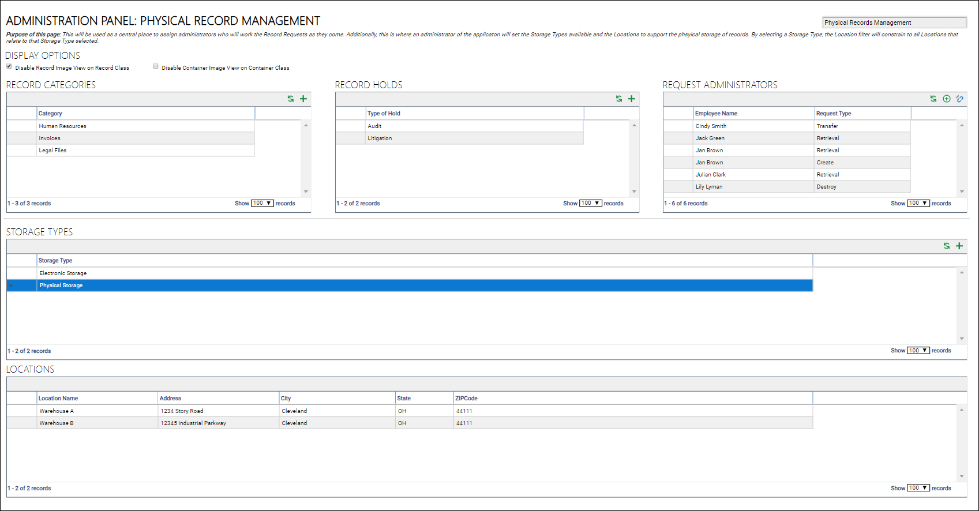

1. **Click on the Physical Storage type** to show all of the locations of this type.

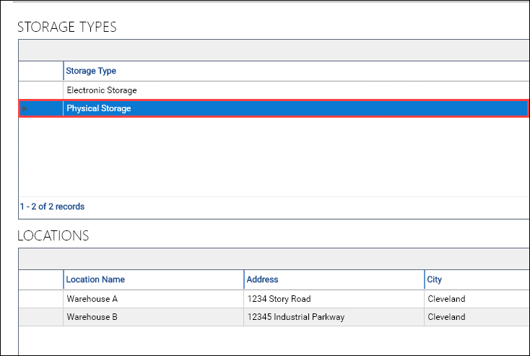

1. **Double click on Warehouse B** from the Result Status filter to open the object.

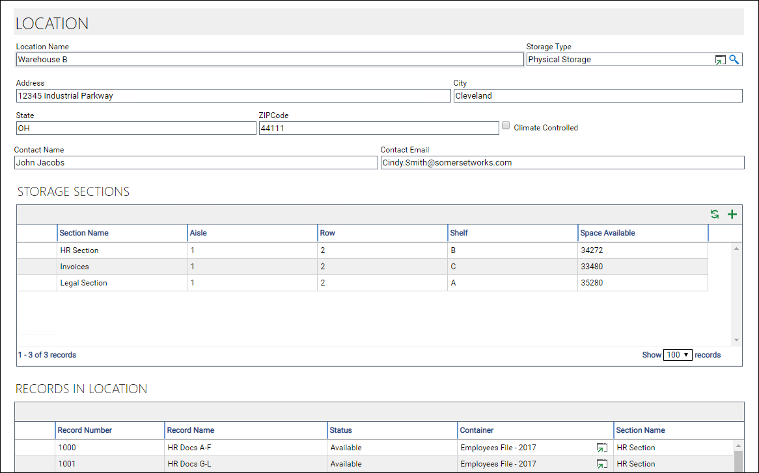

Notice that within each location are Storage Sections. A Storage Section can be used to groupings of similar physical records. By clicking on a Storage Section you can see the records that are related.

1. **Double click Legal Section to open it.**

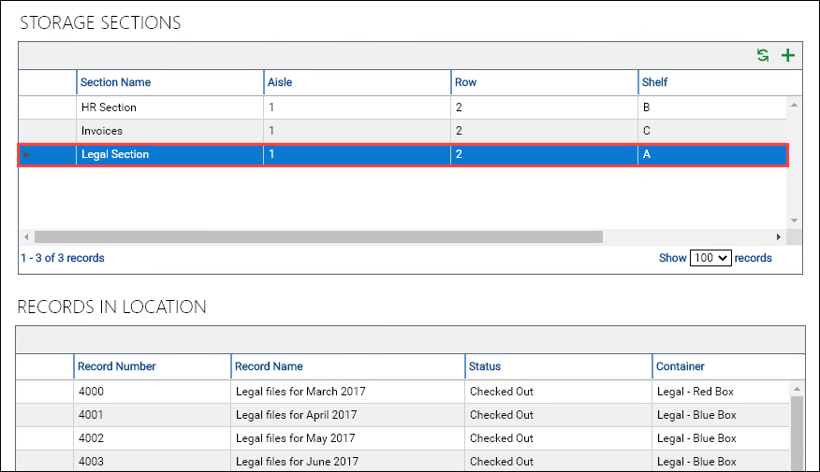

Within each Storage Section are the Containers. Containers represent the physical space that contain the physical records themselves. Notice that each container has dimensions which can be used to calculate the overall space that a Container consumes, as well as how much space is remaining. The total space for an entire Location can also be calculated (which can be found on the Location screen) to determine how the space is being utilized.

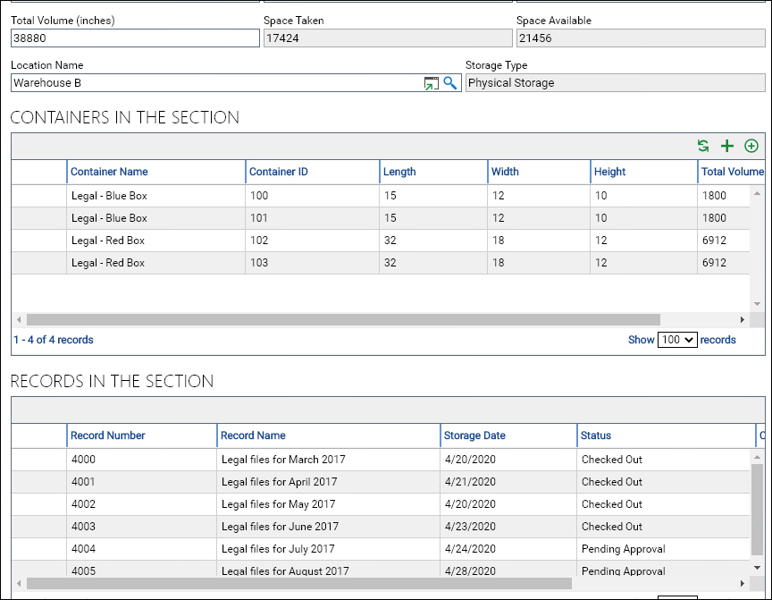

Administrators can also create new containers from here, or they can assign an existing container to this Storage Section (in the case where a physical records is moved from one location to another).

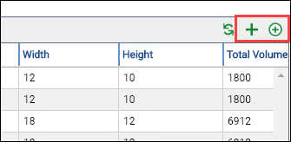

1. Double click Legal - Box Blue - 100 to open up the object in order to view all the records located within the container.

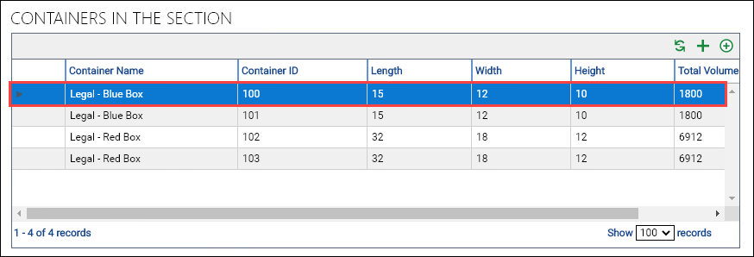

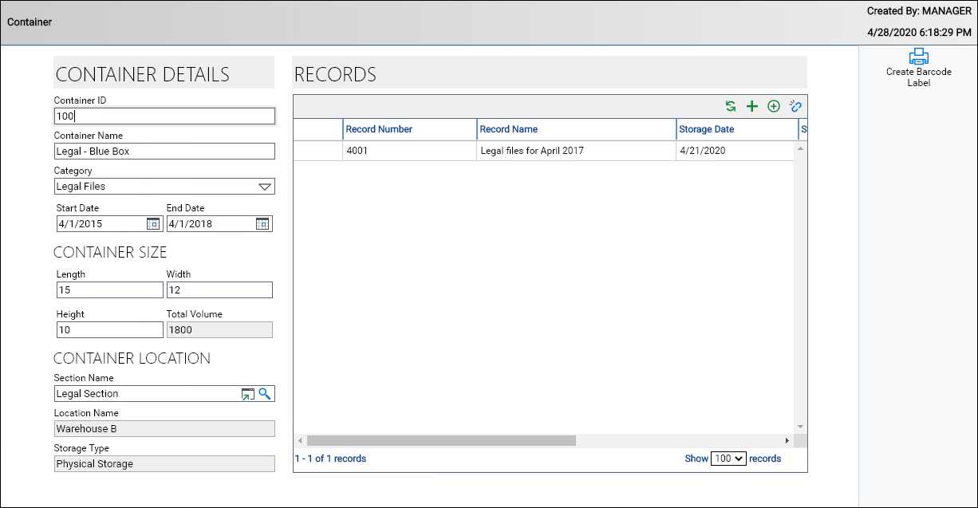

# Notifications

Notifications are used as way to communicate to the employee and locations throughout the application. There is a mix between automatic notifications and manual notifications within the solution. On submit of a request, the requestor will receive a notification to confirm the request has been received.

Additionally, if using the communication portion within the application you can send ad hoc notifications. Examples of each can be see below.

1. Open Microsoft Outlook and navigate to the Employee@9SecondFoods inbox.



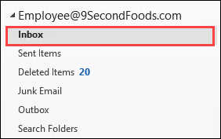

In the inbox are the email notifications that have been configured for this demonstration. Notice that an email was sent after submit of the form to the requestor.

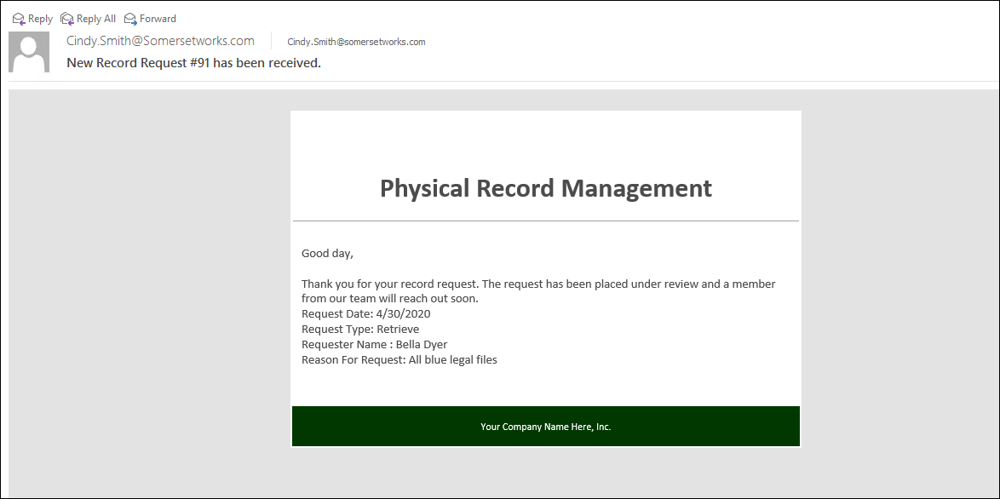

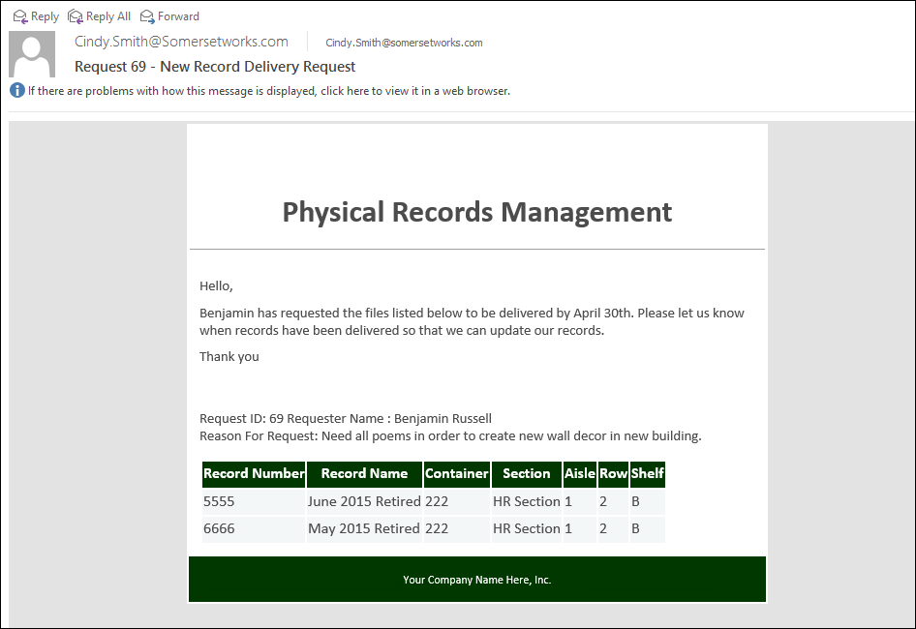

Please note that the email may take a few seconds to appear. You can refresh the email inbox by clicking the icon shown below.

